Lab – Automated Configuration Backup, Change, Verification, and Rollback

Objectives
Part 1: Install required Python modules
Part 2: Connect to IOS XE device using SSH
Part 3: Back up device configuration
Part 4: Apply configuration change
Part 5: Verify configuration change
Part 6: Implement rollback mechanism

Background / Scenario
In modern networking environments, automation is widely used to perform configuration changes quickly and consistently. However, automation introduces risk—if a change is incorrect, it can impact network stability or cause outages.
To address this, network engineers use safe automation workflows that include:
- Backing up the current configuration
- Applying controlled changes
- Verifying results
- Rolling back if something goes wrong
In this lab, you will implement a complete automation workflow using Python. You will interact with a Cisco IOS XE device, apply a configuration change, and ensure that the change can be safely reversed if validation fails.

Required Resources
- Cisco IOS XE device (NDG Netlab DevNet environment)
- Linux terminal
- Python 3.x
- Internet access

Instructions

Part 1: Install Required Python Module
Step 1: Install Netmiko
Netmiko is a Python library that simplifies SSH communication with network devices. It allows automation scripts to send commands and receive output, similar to working in the CLI.
a. Open a Linux terminal
b. Install Netmiko:
pip3 install netmiko
c. Verify installation:
python3 -c "import netmiko"
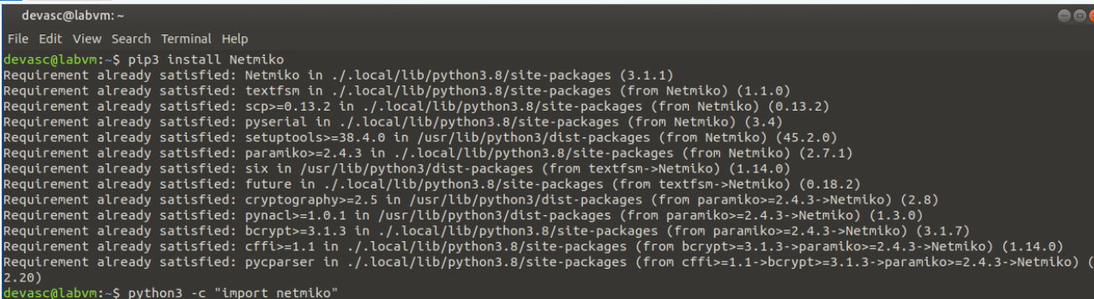
Why this matters:
Automation requires a way to communicate with network devices. Netmiko provides a simple interface for sending commands programmatically.

Part 2: Connect to IOS XE Device
Step 1: Discover IP address of IOS XE Device
- Launch the CSR 1000V
- Take note of the of the IP address given. We will need this later
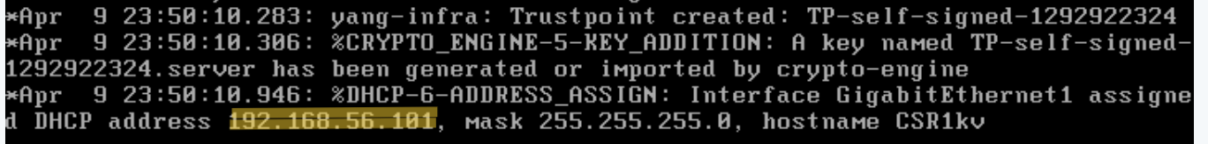

Create a Python Script
a. Create a new file:
nano automation.py
b. Add the following code:
from netmiko import ConnectHandler

device = {
"device_type": "cisco_ios",
"host": "DEVICE_IP",
"username": "cisco",
"password": "cisco123!"
}

connection = ConnectHandler(**device)
print("Connected successfully")
c. Run the script:
python3 automation.py
What this does:
- Establishes an SSH session to the network device
- Creates a connection object for automation
Why this matters:
Automation begins with connectivity. Without a reliable connection, no automated task can be executed.

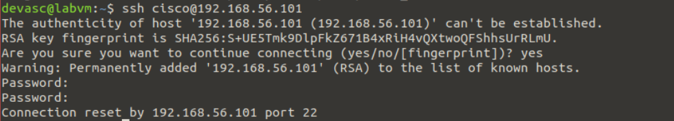

Part 3: Back Up Device Configuration
Step 1: Retrieve Running Configuration
a. Add the following code:
output = connection.send_command("show running-config")

with open("backup_config.txt", "w") as f:
f.write(output)

print("Backup completed")
b. Run the script
What this does:
- Executes a CLI command
- Saves device configuration to a file
Why this matters:
Before making any change, you must have a backup. This provides a recovery point if something goes wrong.

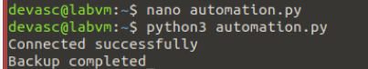
Part 4: Save Device Checkpoint
Step 1: Create On-Device Backup
a. Add:
checkpoint = connection.send_command_timing(
"copy running-config flash:backup_config.cfg"
)

if "Destination filename" in checkpoint:
checkpoint += connection.send_command_timing("\n")

print("Checkpoint created")
b. Run the script
What this does:
- Saves configuration directly on the device
Why this matters:
A local file is useful, but a device checkpoint allows fast rollback, which is critical in production networks.

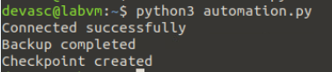
Part 5: Apply Configuration Change
Step 1: Modify Hostname
a. Add:
connection.send_config_set(["hostname NETLAB-R1"])
print("Configuration change applied")
b. Run the script
What this does:
- Sends configuration commands to the device
Why this matters:
This simulates a real automation task—making a controlled network change.

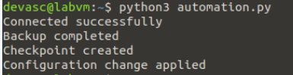
Part 6: Verify Configuration Change
Step 1: Validate Change
a. Add:
verify = connection.send_command("show running-config | include hostname")
print(verify)
b. Run the script
What this does:
- Confirms that the change was successfully applied
Why this matters:
Automation without validation is dangerous. Verification ensures the network is in the expected state.

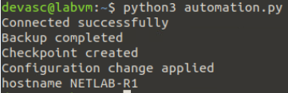
Part 7: Implement Rollback
Step 1: Add Validation Logic
a. Modify your script:
if "hostname NETLAB-R1" in verify:
print("Verification successful")
else:
print("Verification failed")
print("Starting rollback...")

rollback = connection.send_command_timing(
"configure replace flash:backup_config.cfg force"
)

if "confirm" in rollback.lower():
rollback += connection.send_command_timing("\n")

print("Rollback completed")

Step 2: Trigger Failure
- Modify the script to force verification failure
  - Modify the “if” statement to change the hostname that it is trying to detect
If “hostname NETLAB” in verify:
b. Save and run the script
What this does:
- Detects failure
- Restores previous configuration
Why this matters:
Rollback is the most critical safety mechanism in automation. It ensures that failed changes do not impact the network.

Success -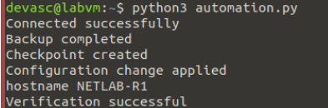FF
Failure - 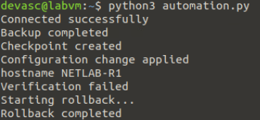
📸 Screenshot 7: Original hostname restored

Summary
In this lab, you implemented a safe automation workflow that includes:
- Backup
- Change
- Verification
- Rollback
This reflects real-world network automation practices used to minimize risk and ensure reliability.

